Topic: Students need to take breaks to do things other than just studying.

Good morning, everyone!

I’m Jayden. Today, I deliver the speech on “Students need to take breaks

to do things other just studying”. There is no doubt that taking breaks is

important. Recently, I have read many passages about it and I also

communicate with my classmates about the issue. I will analysis the

importance from two aspects.

Taking breaks can improve efficiency of study.

Tricia Lockhart, a PGCE tutor at king’s college who has taught in UK for

thirty-three years, has ever carried a research. She found that when you

first start, it takes 15 minutes to get to peak concentration assuming you

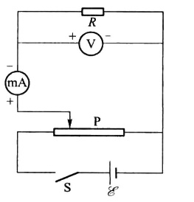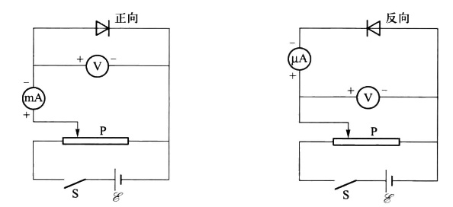for about 30-40 minutes after which effectiveness drops off. However, if

**图一 图二 图三**